Complete

Python for Beginners



Notes

PYTHON TUTORIAL FOR BEGINNERS

Chapter - 01 Introduction to Python
- What is programming
- What is Python
- Popular programming languages
- Why Python
- Career with Python

What is Programming Language?

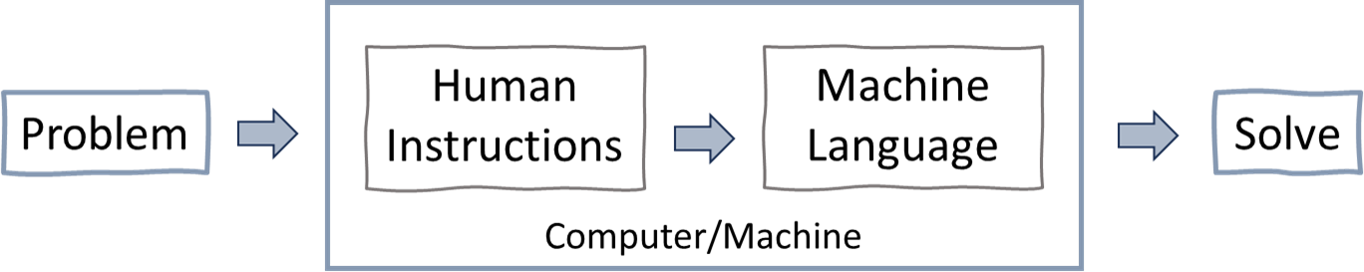
Programming is the process of creating sets of instructions that tell a computer how to perform specific tasks. These instructions, known as code, are written in programming languages that computer understand and executes to carry out various operations, such as solving problems, analysing data, or controlling device.
Popular programming languages: Python, C, C++, Java, Go, C#, etc.

What is Python?
Python is a high-level programming language known for its simplicity and readability.
Just like we use Hindi language to communicate and express ourselves,
Python is a language for computers to understand our instructions & perform tasks.
Note: Python was created by Guido van Rossum in 1991.

Popular programming languages
As per statistic survey, Python is the most popular programming language.

Why Python?
Python is one of the easiest programming languages to learn and known for its versatility and user-friendly syntax, is a top choice among programmers.
Also, python is an open source (free) programming language and have extensive libraries to make programming easy. Python has massive use across different industries with excellent job opportunities.

Python is Dynamically Typed Example
In Python there is no declaration of a variable, just an assignment statement. x = 8 # here x is a integer
x = "Python by Rishabh Mishra" # here x is a string
print(type(x)) # you can check the type of x

Python - Easy to Read & Write
Ques1: Write a program to print “Hello World”

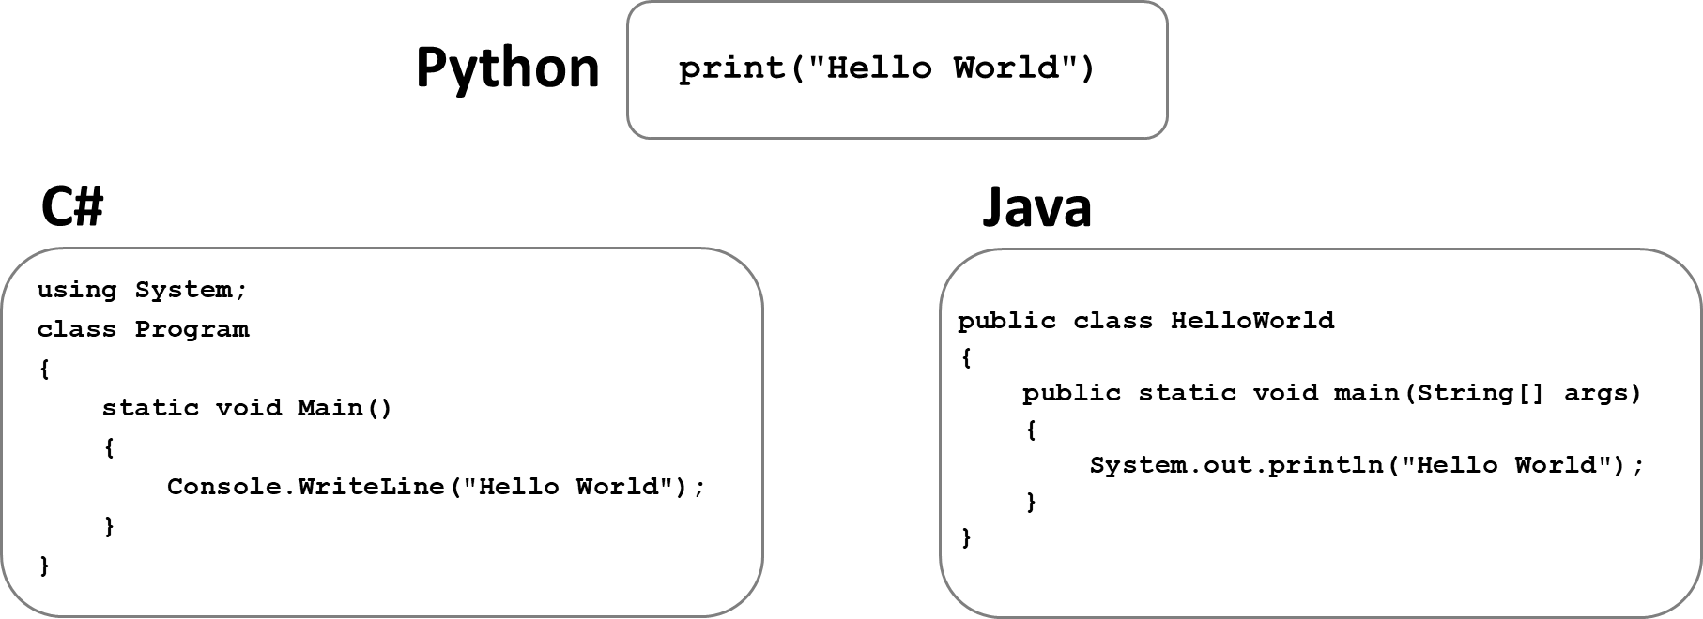

Ques2: Write a program to print numbers from 1 to 10

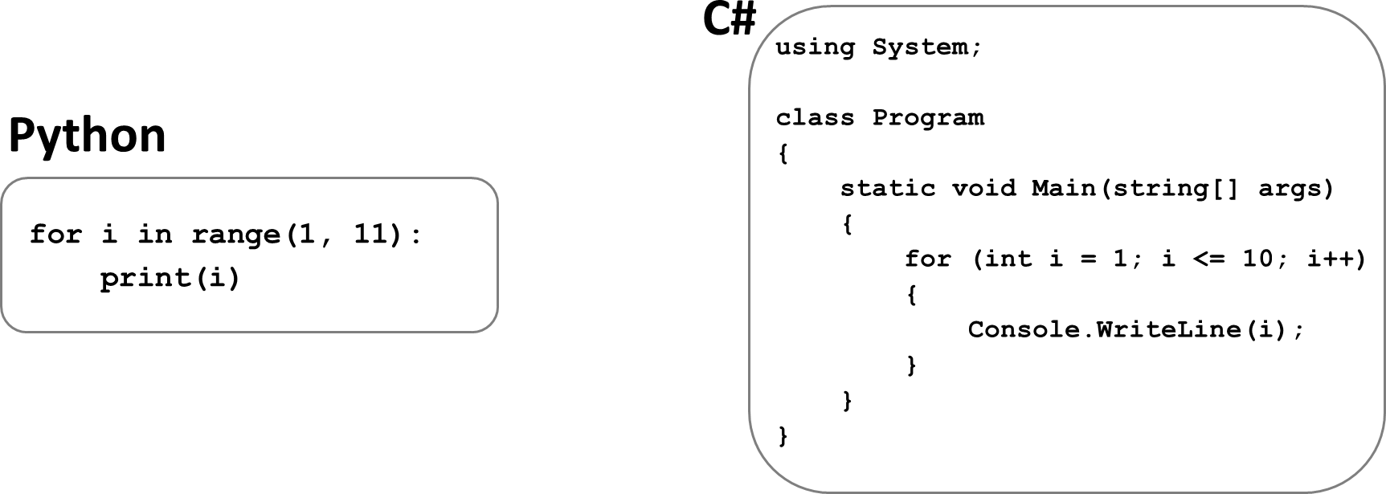

In above examples we can see that Python is simple in writing & reading the code.

Careers with Python
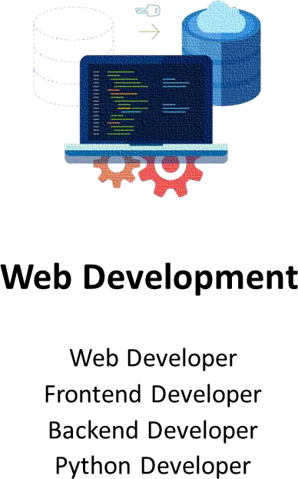
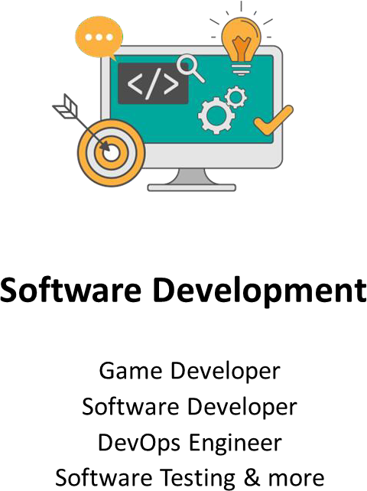

Python is not only one of the most popular programming languages in the world, but it also offers great career opportunities. The demand for Python developers is growing every year.

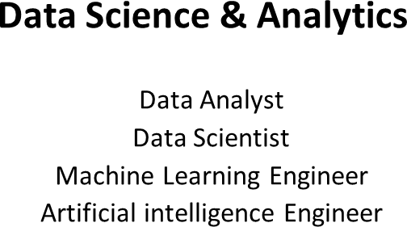

PYTHON TUTORIAL FOR BEGINNERS

Chapter - 02
Python Installation & Setup + Visual Studio Code Installation
- Python installation
- Visual Studio Code installation

Install Python
Step 1: Go to website: https://www.python.org/downloads/ Step 2: Click on “Download Python” button
(Download the latest version for Windows or macOS or Linux or other) Step 3: Run Executable Installer
Step 4: Add Python to Path
Step 5: Verify Python Was Installed on Windows
Open the command prompt and run the following command:

python --version

Install Python IDE (code editor)
Step 1: Go to website: https://code.visualstudio.com/download Step 2: Click on “Download” button
(Download the latest version for Windows or mac or Linux or other) Step 3: Run Executable Installer
Step 4: Click “Add to Path”
Step 5: Finish & launch the app
Popular Python IDE: VS Code, PyCharm, Jupyter Notebook & more

PYTHON TUTORIAL FOR BEGINNERS


Chapter - 03
First Python Program
- Print- Hello World!
- Python As a Calculator
- Running the Python code
- Python Execution Steps
- Interpreter v/s Compiler

First Python Program - Hello World
Printing "Hello World" as the first program in Python.
print is a keyword word that has special meaning for Python. It means, "Display what’s inside the parentheses."
print("Hello World")

Instructor = "Rishabh Mishra" print("Python by", Instructor, sep="-")

Python As a Calculator
Python can be used as a powerful calculator for performing a wide range of arithmetic operations.
2+5 # add two numbers print(10/5) # divide two numbers
# print sum of two numbers
a = 2
b = 5 print(a+b)

Comments: Comments are used to annotate codes, and they are not interpreted by Python. It starts with the hash character #
Comments are used as notes or short descriptions along with the code to increase its readability.

Running the Python Code
- Create a new text file and inside it write – print(“Welcome to the Python Course by Rishabh Mishra”)
- Save file with extension .py – firstcode.py
- Open command prompt on windows (or Terminal on MacOS)
- Enter the location where firstcode.py file is saved – cd downloads
- Finally run the file as – python firstcode.py

Python Execution Flow

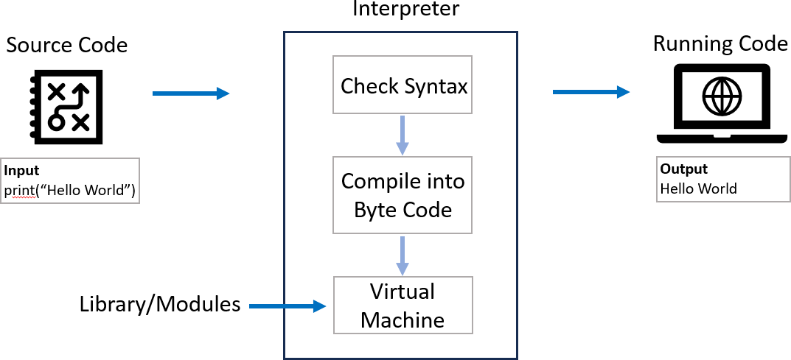

Python Code Execution Steps

- Lexical Analysis: The interpreter breaks down the code into smaller parts called tokens, identifying words, numbers, symbols, and punctuation.
- Syntax Parsing: It checks the structure of the code to ensure it follows the rules of Python syntax. If there are any errors, like missing parentheses or incorrect indentation, it stops and shows a SyntaxError.
- Bytecode Generation: Once the code is validated, the interpreter translates it into a simpler set of instructions called bytecode. This bytecode is easier for the computer to understand and execute.
- Execution by PVM: The Python Virtual Machine (PVM) takes the bytecode and runs it step by step. It follows the instructions and performs calculations, assigns values to variables, and executes functions.
- Error Handling and Output: If there are any errors during execution, like trying to divide by zero or accessing a variable that doesn't exist, the
interpreter raises an exception. If the code runs without errors, it displays any output, such as printed messages or returned values, to the user.

Python Syntax

The syntax of the Python programming language, is the set of rules that defines how a Python program will be written and interpreted (by both the runtime system & by human readers).
my_name = "Madhav"
my_name = Madhav
# Use quotes "" for strings in Python

Interpreter vs Compiler

Interpreter | Compiler
An interpreter translates and executes a source code line by line as the code runs. | A compiler translates the entire code into machine code before the program runs.
Execution: Line by line. | Execution: Entire program at once.
Speed: Slower execution because it translates each line on the fly. | Speed: Faster execution because it translates the entire program at once.
Debugging: Easier to debug as it stops at the first error encountered. | Debugging: Harder to debug  because errors are reported after the entire code is compiled
Examples: Python, Ruby, JavaScript, and PHP. | Examples: C, C++, Java, and Go.

PYTHON TUTORIAL FOR BEGINNERS

Chapter - 04
Variables in Python
- What is a Variable
- Variables - examples
- Variable Naming Rules

Variables in Python
A variable in Python is a symbolic name that is a reference or pointer to an object.
In simple terms, variables are like containers that you can fill in with different types of data values. Once a variable is assigned a value, you can use that variable in place of the value.
We assign value to a variable using the assignment operator (=).
Syntax: variable_name = value Example: greeting = "Hello World"
print(greeting)

Variable Examples
Python can be used as a powerful calculator for performing a wide range of arithmetic operations.

PythonLevel | = | "Beginner" | # | pascal case
pythonLevel | = | "Beginner" | # | camel case
pythonlevel | = | "Beginner" | # | flat case
python_level | = | "Beginner" | # | Snake case

x = 10
print(x+1) # add number to a variable

a, b, c = 1, 2, 3
print(a, b, c) # assign multiple variables

Variable Naming Rules
- Must start with a letter or an underscore ( _ ).
- Can contain letters, numbers, and underscores.
- Case-sensitive (my_name and my_Name are different).
- Cannot be a reserved keyword (like for, if, while, etc.).

_my_name = "Madhav"
for = 26

# ‘for’ is a reserved word in Python

PYTHON TUTORIAL FOR BEGINNERS
Chapter - 05
Data Types in Python
- What are Data types
- Types of data types
- Data types examples

Data Types in Python
In Python, a data type is a classification that specifies the type of value a variable can hold. We can check data type using type() function.
Examples:
- my_name = "Madhav"
>>> type(my_name) O/P: <class 'str’>
- value = 101
>>> type(value) O/P: <class 'int'>

Basic Data Types in Python
Python can be used as a powerful calculator for performing a wide range of arithmetic operations.
- Numeric: Integer, Float, Complex
- Sequence: String, List, Tuple
- Dictionary
- Set
- Boolean
- Binary: Bytes, Bytearray, Memoryview

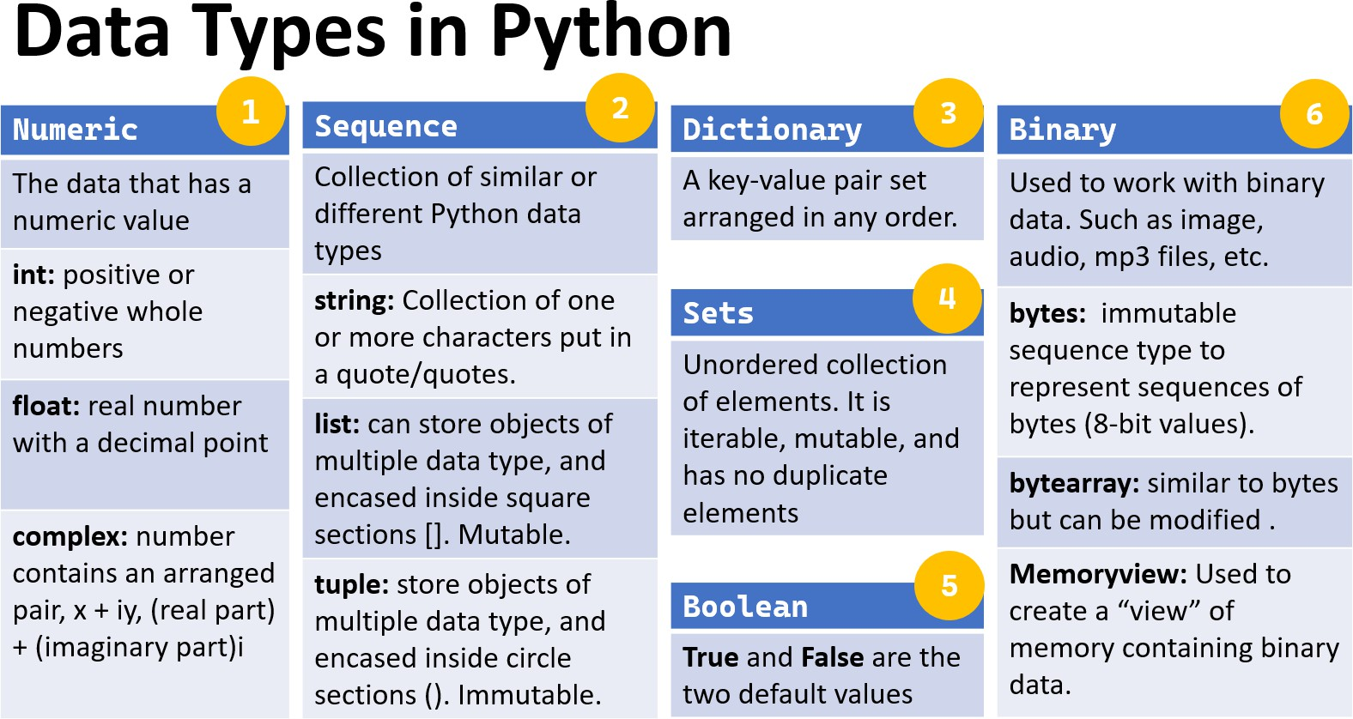

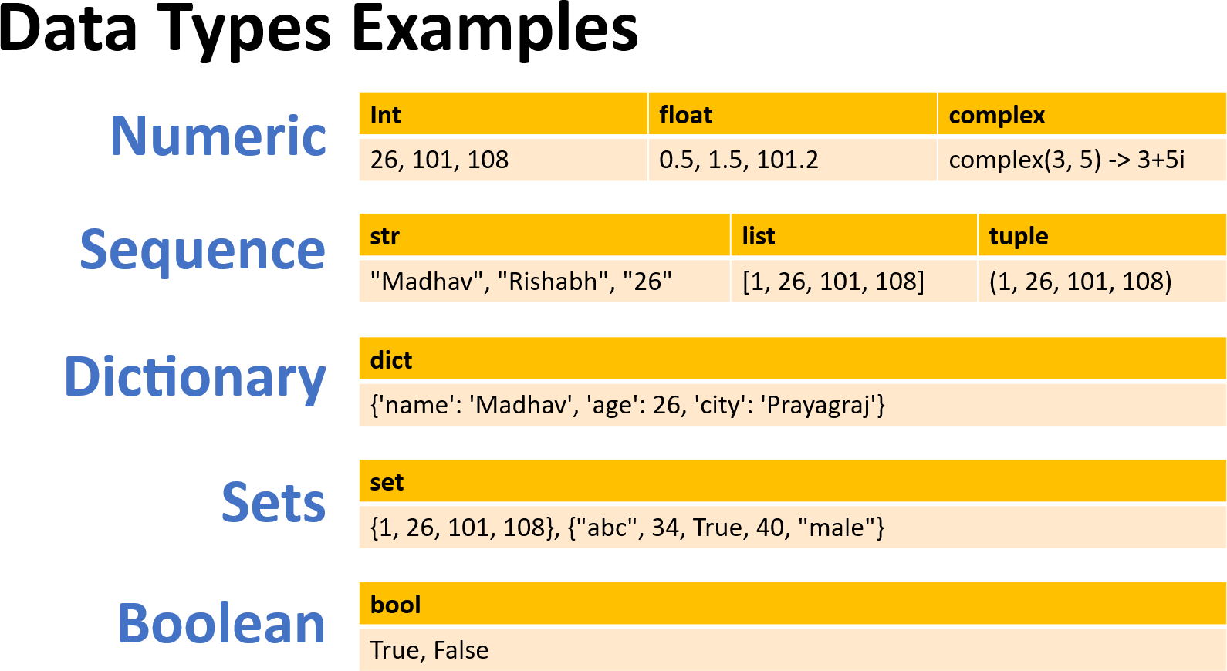

PYTHON TUTORIAL FOR BEGINNERS
Chapter - 06
Type Casting in Python
- What is type casting
- Type Casting examples
- Type Casting - Types

Type Casting
Type casting in Python refers to the process of converting a value from one data type to another. This can be useful in various situations, such as when you need to perform operations between different types or when you need to format data in a specific way. Also known as data type conversion.
Python has several built-in functions for type casting:
int(): Converts a value to an integer.
float(): Converts a value to a floating-point number. str(): Converts a value to a string.
list(), tuple(), set(), dict() and bool()

Type Casting Examples
Basic examples of type casting in python:
# Converting String to Integer: str_num = "26"
int_num = int(str_num) print(int_num) # Output: 26
print(type(int_num)) # Output: <class 'int'>

# Converting Float to Integer:
float_num = 108.56 int_num = int(float_num)
print(int_num) # Output: 108 print(type(int_num)) # Output: <class 'int'>

Types of Typecasting
There are two types of type casting in python:
- Implicit type casting
- Explicit type casting

Implicit Type Casting
Also known as coercion, is performed automatically by the Python interpreter. This usually occurs when performing operations between different data types, and Python implicitly converts one data type to another to avoid data loss or errors.

# Implicit type casting from integer to float num_int = 10
num_float = 5.5
result = num_int + num_float # Integer is automatically converted to float
print(result) # Output: 15.5 print(type(result)) # Output: <class 'float'>

Explicit Type Casting
Also known as type conversion, is performed manually by the programmer using built-in functions. This is done to ensure the desired type conversion and to avoid unexpected behavior.

# Converting String to Integer: str_num = "26"

int_num = int(str_num) print(int_num) # Output: 26
print(type(int_num)) # Output: <class 'int’>

# Converting a value to boolean: bool(0) # Output: False
bool(1) # Output: True

PYTHON TUTORIAL FOR BEGINNERS

Chapter - 07
Input Function in Python
- Input Function – Definition
- Input Function – Example
- Handling Different Data Types

Input Function in Python
The input function is an essential feature in Python that allows to take input from the user. This is particularly useful when you want to create interactive programs where the user can provide data during execution.
Also known as user input function. How input Function Works:
The input function waits for the user to type something and then press Enter. It reads the input as a string and returns it.
Example:
# Prompting the user for their name name = input("Enter your name: ")
# Displaying the user's input print("Hello, " + name + "!")

Input Function – Add 2 Numbers
A simple program that takes two numbers as input from the user and prints their sum.
# Prompting the user for the first and second number num1 = input("Enter the first number: ")
num2 = input("Enter the second number: ")

# Since input() returns a string, we need to convert it to an integer
num1 = int(num1) num2 = int(num2)
# Calculating the sum and display the result
sum = num1 + num2
print("The sum of", num1, "and", num2, "is:", sum)

Multiple Input from User & Handling different Data Types
# input from user to add two number and print result x = input("Enter first number: ")
y = input("Enter second number: ")
# casting input numbers to int, to perform sum print(f"Sum of {x} & {y} is {int(x) + int(y)}")

Home Work – User input and print result
Write a program to input student name and marks of 3 subjects. Print name and percentage in output.
# Prompting the user for their name and 3 subject marks name = input("Enter your name: ") hindi_marks = input("Enter Hindi Marks: ") maths_marks = input("Enter Maths Marks: ")
science_marks = input("Enter Science Marks: ")
# Calculating percentage for 3 subjects
percentage = ((int(hindi_marks) + int(maths_marks) + int(science_marks))/300)*100
# Printing the final results
print(f"{name}, have {percentage}%. Well done & keep working hard!!")

PYTHON TUTORIAL FOR BEGINNERS
Chapter - 08
Operators in Python
- What are Operators
- Types of Operators
- Operators Examples

Operators in Python
Operators in Python are special symbols or keywords used to perform operations on operands (variables and values).
Operators: These are the special symbols/keywords. Eg: + , * , /, etc.
Operand: It is the value on which the operator is applied.
# Examples

Addition operator '+': | a | + b
Equal operator '==': | a | == b
and operator 'and': | a | > 10 and b < 20

Types of Operators
Python supports various types of operators, which can be broadly categorized as:
- Arithmetic Operators
- Comparison (Relational) Operators
- Assignment Operators
- Logical Operators
- Bitwise Operators
- Identity Operators
- Membership Operators

Operators Cheat Sheet

Operator | Description
() | Parentheses
** | Exponentiation
+, -, ~ | Positive, Negative, Bitwise NOT
*, /, //, % | Multiplication, Division, Floor Division, Modulus
+, - | Addition, Subtraction
==, !=, >, >=, <, <= | Comparison operators
is, is not, in, not in | Identity, Membership Operators
NOT, AND, OR | Logical NOT, Logical AND, Logical OR
<<, >> | Bitwise Left Shift, Bitwise Right Shift
&, ^, | | Bitwise AND, Bitwise XOR, Bitwise OR

- Arithmetic Operators
Arithmetic operators are used with numeric values to perform mathematical operations such as addition, subtraction, multiplication, and division.
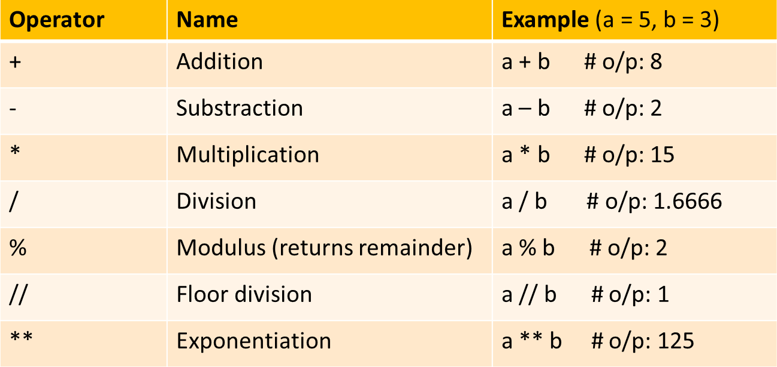

Precedence of Arithmetic Operators in Python:
P – Parentheses
E – Exponentiation M – Multiplication D – Division
A – Addition
S – Subtraction

Comparison (Relational) Operators
Comparison operators are used to compare two values and return a Boolean result (True or False).
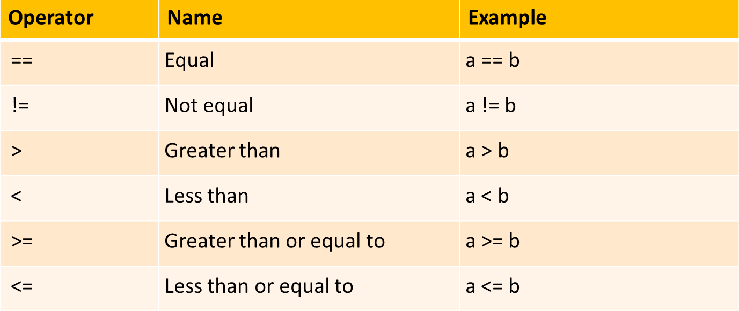

Assignment Operators
Assignment operators are used to assign values to variables.
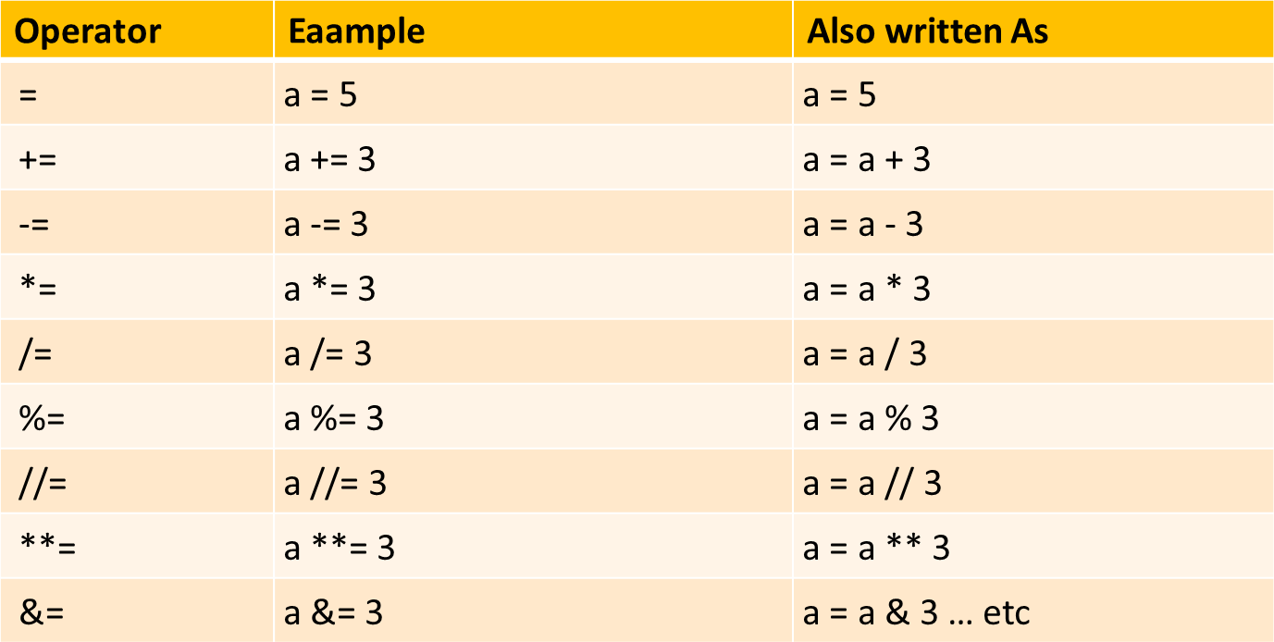

Logical Operators
Logical operators are used to combine conditional statements.
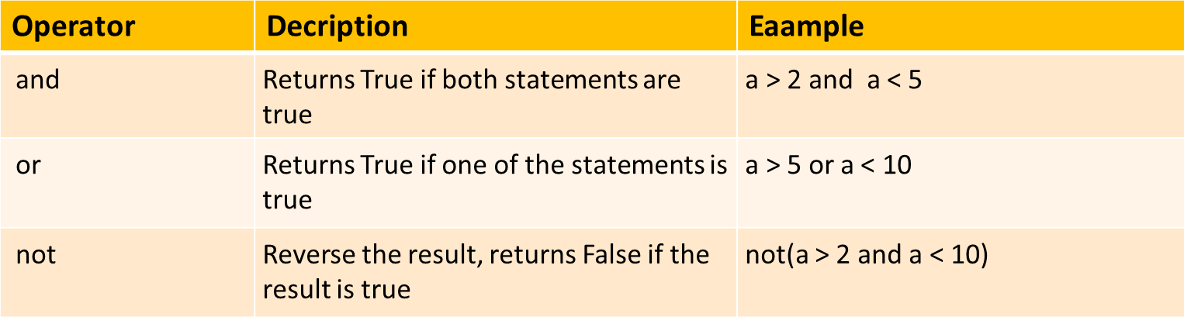

Identity & Membership Operators
Identity operators are used to compare the memory locations of two objects, not just equal but if they are the same objects.
Membership operators checks whether a given value is a member of a sequence (such as strings, lists, and tuples) or not.
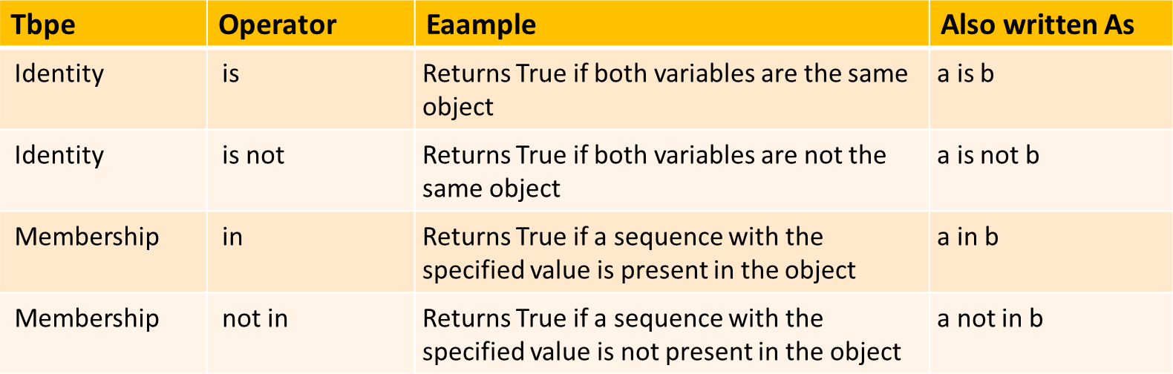

Bitwise Operators
Bitwise operators perform operations on binary numbers.
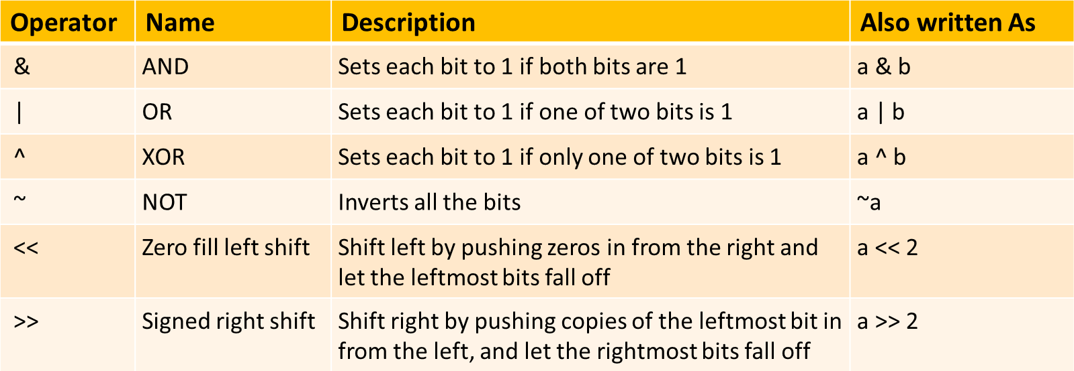

Bitwise Operators Example:
# Rules: 0 – False, 1 | - True | Eg:2
True + True = True |  | a = 5 |  | # | 0101
True + False = False |  | b = 8 |  | # | 1000
False + False = False |  | print(a | & b)
 |  | # Output: 0 # 0000

# Compare each bit in these numbers. |  |  |  |  |  |  |  |  | Eg:1
0101 | (This | is | 5 | in | binary) |  |  |  | a = 5 | # |  | 0101
0011 | (This | is | 3 | in | binary) |  |  |  | b = 3 | # |  | 0011
------- |  |  |  |  |  |  |  |  | print(a & | b)
0001 (This |  | is | the result of |  |  | 5 | & | 3) | # Output: | 1 | # | 0001

PYTHON TUTORIAL FOR BEGINNERS
Chapter - 09
Conditional Statements in Python
- Conditional Statement definition
- Types of Conditional Statement
- Conditional Statement examples

Conditional Statements in Python
Conditional statements allow you to execute code based on condition evaluates to True or False. They are essential for controlling the flow of a program and making decisions based on different inputs or conditions.
# Examples
a = 26
b = 108
if b > a:
print("b is greater than a")
# Indentation - whitespace at the beginning of a line

Types of Conditional Statements
There are 5 types of conditional statements in Python:
  - 'if' Statement
  - 'if-else' statement
  - 'if-elif-else' statement
  - Nested 'if else' statement
  - Conditional Expressions (Ternary Operator)

'if' Conditional Statement
The if statement is used to test a condition and execute a block of code only if the condition is true.

Syntax:
if condition:
# Code to execute if the condition is true

Example:
age = 26
if age > 19:
print("You are an adult")

'if' statement flow diagram:

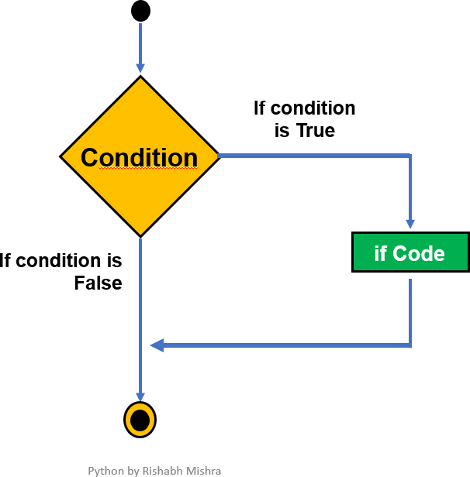

'if-else' Conditional Statement
The if-else statement provides an alternative block of code to execute if the condition is false.

Syntax:
if condition:
# Code to execute if the condition is true else:
# Code to execute if the condition is false

Example:
temperature = 30
if temperature > 25: print("It's a hot day.")
else:
print("It's a cool day.")

'if-else' statement flow diagram:

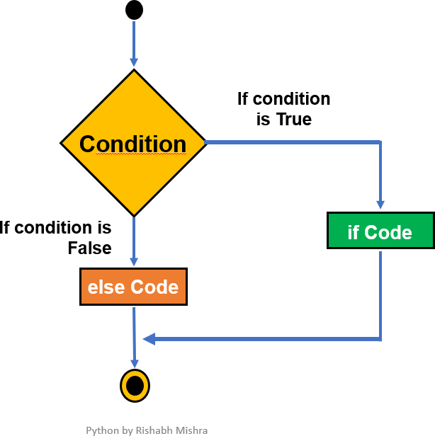

'if-elif-else' Conditional Statement
The if-elif-else statement allows to check multiple conditions and execute different blocks of code based on which condition is true.

Syntax:
if condition1:
# Code to execute if condition1 is true elif condition2:
# Code to execute if condition2 is true else:
# Code to execute if none of the above conditions are true

Example:
Grading system: Let’s write a code to classify the student’s grade based on their total marks (out of hundred).
score = 85
if score >= 90: print("Grade - A")
elif score >= 80: print("Grade - B")
elif score >= 70: print("Grade - C")
else:
print("Grade - D")

Nested 'if-else' Conditional Statement
A nested if-else statement in Python involves placing an if-else statement inside another if-else statement. This allows for more complex decision-making by checking multiple conditions that depend on each other.

Syntax:
if condition1:
# Code block for condition1 being True if condition2:
# Code block for condition2 being True else:
# Code block for condition2 being False
else:
# Code block for condition1 being False
... ..

Example:
Number Classification: Let's say you want to classify a number as positive, negative, or zero and further classify positive numbers as even or odd.
number = 10
if number > 0: # First check if the number is positive
if number % 2 == 0:
print("The number is positive and even.") else:
print("The number is positive and odd.") else: # The number is not positive
if number == 0:
print("The number is zero.") else:
print("The number is negative.")

Conditional Expressions
Conditional expressions provide a shorthand way to write simple if-else statements. Also known as Ternary Operator.

Syntax:
value_if_true if condition else value_if_false

Example:
age = 16
status = "Adult" if age >= 18 else "Minor" print(status)

Conditional Statements- HW
Q1: what is expected output and reason?
value = None

if value:
print("Value is True") else:
print("Value is False")

Q2: write a simple program to determine if a given year is a leap year using user input.

PYTHON TUTORIAL FOR BEGINNERS
Chapter - 10
Functions in Python
- Functions definition
- Types of Functions
- Function examples

Functions in Python
A function is a block of code that performs a specific task. You can use it whenever you want by calling its name, which saves you from writing the same code multiple times.
Benefits of Using Function: Increases code Readability & Reusability. Basic Concepts:
  - Create function: Use the def keyword to define a function.
  - Call function: Use the function's name followed by () to run it.
  - Parameter: The variable listed inside parentheses in function definition.
  - Argument: The actual value you pass to function when you call it.

Types of Functions
Below are the two types of functions in Python:
- Built-in library function:
  - These are Standard functions in Python that are available to use.
  - Examples: print(), input(), type(), sum(), max(), etc
- User-defined function:
  - We can create our own functions based on our requirements.
  - Examples: create your own function :)

Syntax:
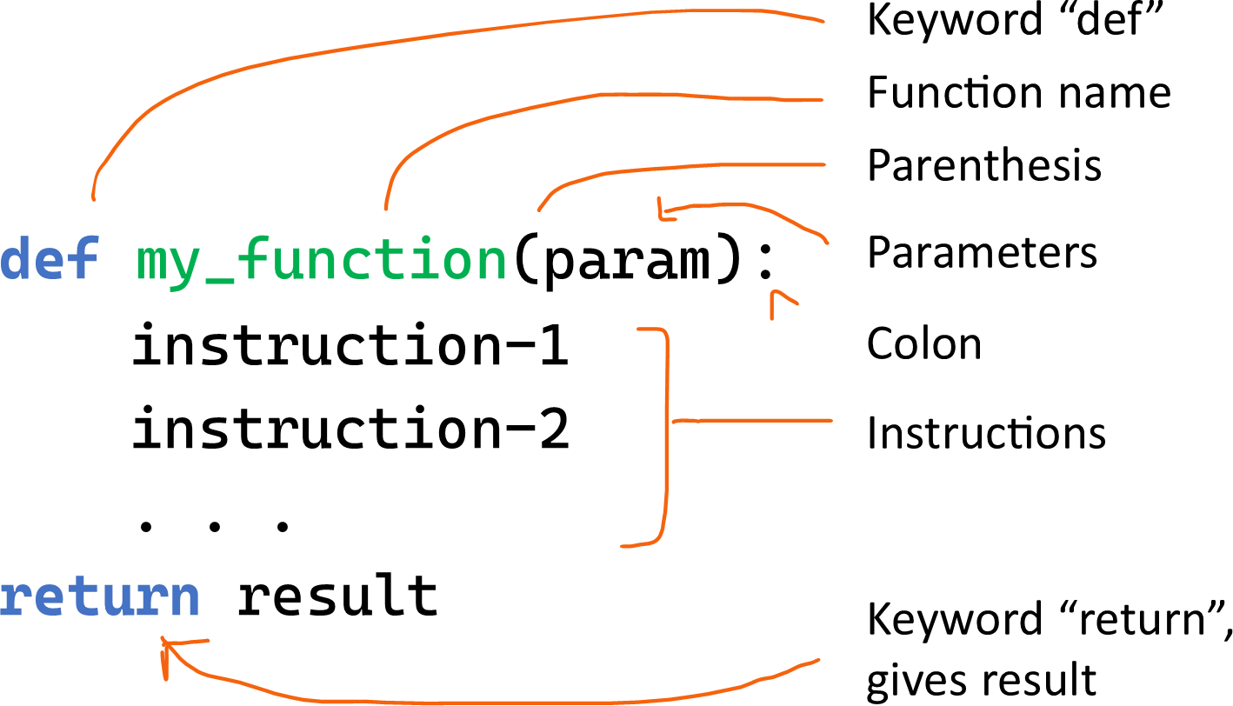

# return result is optional, Use if you want the function to give back a value

Function without Parameters
Example:1

# Create or Define Function
def greetings():
print("Welcome to Python tutorial by Rishabh")

# Use or call this Function
greetings()

# Output: Welcome to Python tutorial by Rishabh

Function with Parameters
Example:2

# function to adds two numbers & print result. def add2numbers(a, b):
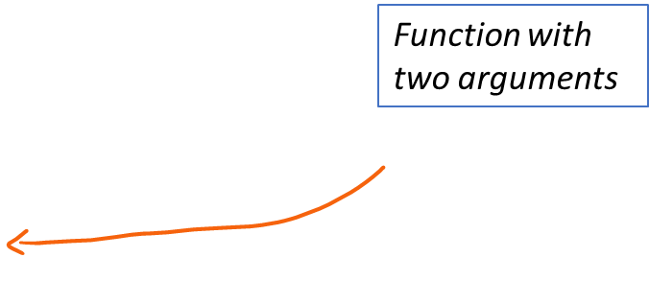
result = a + b
print("The sum is:", result)

# Calling this function with arguments add2numbers(5, 3)
# Output: The sum is: 8

The return Statement
The return statement is used in a function to send a result back to the place where the function was called. When return is executed, the function stops running and immediately returns the specified value.
Example:
def add(a, b):
return a + b # This line sends back sum of a and b
result = add(3, 5) print(result)

# Output: 8

Function with a Return value
Example:3

# function to convert Celsius to Fahrenheit
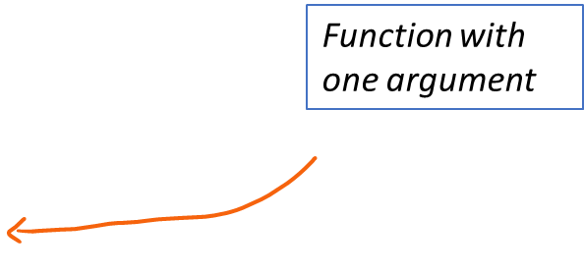
def celsius_to_fahrenheit(celsius): fahrenheit = (celsius * 9/5) + 32 return Fahrenheit

value
# Calling this function to return a
temp_f = celsius_to_fahrenheit(25) print("Temperature in Fahrenheit:", temp_f)
# Output: Temperature in Fahrenheit: 77.0

The pass Statement
The pass statement is a placeholder in a function or loop. It does nothing and is used when you need to write code that will be added later or to define an empty function.
Example:

def myfunction():
pass # This does nothing for now

Functions – HW
Write a Python program to create a calculator that can perform at least five
different mathematical operations such as addition, subtraction, multiplication, division and average. Ensure that the program is user-friendly, prompting for input and displaying the results clearly.

PYTHON TUTORIAL FOR BEGINNERS
Chapter - 11
Function Arguments in Python
- Function Arguments
- Types of Functions Arguments
- Function Arguments examples

Arguments in Function
Arguments are the values that are passed into a function when it’s called. A function must be called with the right number of arguments. If a function has 2 parameters, you must provide 2 arguments when calling it.

Example: function defined using one parameter (variable)

def greetings(name): # name is a parameter
print("Hello, " + name + "!")

greetings("Madhav") # Madhav as argument
# Output: Hello, Madhav!

Types of Function Arguments
Python supports various types of arguments that can be passed at the time of the function call.
- Required arguments (Single/Multiple arguments)
- Default argument
- Keyword arguments (named arguments)
- Arbitrary arguments (variable-length arguments *args and **kwargs)

Required Arguments (same as above)
Required arguments are the arguments passed to a function in correct positional order. A function must be called with the right number of arguments. If a function has 2 parameters, you must provide 2 arguments when calling it.

Example: function defined using one parameter (variable)

def greetings(name): # name is a parameter
print("Hello, " + name + "!")

greetings("Madhav") # Madhav as argument
# Output: Hello, Madhav!

Default Arguments
You can assign default values to arguments in a function definition. If a value isn't
provided when the function is called, the default value is used.
Example: function defined using one parameter & default value
def greetings(name = "World"): # default value
print("Hello, " + name + "!")

greetings() # No argument passed
# Output: Hello, World!

greetings("Madhav") # Madhav as argument
# Output: Hello, Madhav!

Keyword Arguments
When calling a function, you can specify arguments by the parameter name. These are called keyword arguments and can be given in any order.
Example: function defined using two parameters
def divide(a, b): # a,b are 2 parameters
return a / b
result = divide(b=10, a=20) # with keyword arguments
print(result) # Output: 2

result = divide(10, 20) # positional arguments
print(result) # Output: 0.5

Arbitrary Positional Arguments (*args)
If you're unsure how many arguments will be passed, use *args to accept any number of positional arguments.
Purpose: Allows you to pass a variable number of positional arguments. Type: The arguments are stored as a tuple.
Usage: Use when you want to pass multiple values that are accessed by position.

Example 1:
def add_numbers(*args): return sum(args)

# Any number of arguments
result = add_numbers(1, 2, 3, 4)
print(result)# Output: 10

Note: Here, *args collects all the passed arguments into a tuple, & sum() function adds them.

Example 2:
def greetings(*names): for name in names:
print(f"Hello, {name}!") greetings("Madhav", "Rishabh", "Visakha") # Output:
Hello, Madhav! Hello, Rishabh! Hello, Visakha!

Arbitrary Keyword Arguments (**kwargs)
If you want to pass a variable number of keyword arguments, use **kwargs.
Purpose: Allows you to pass a variable number of keyword arguments (arguments with names).
Type: The arguments are stored as a dictionary.
Usage: Use when you want to pass multiple values that are accessed by name.

Example 1:
def print_details(**kwargs):
for key, value in kwargs.items(): print(f"{key}: {value}")
print_details(name="Madhav", age=26, city="Delhi")

# Output:
name: Madhav age: 26 city: Delhi

Example 2:
def shopping_cart(**products): total = 0
print("Items Purchased:")
for item, price in products.items():
print(f"{item}: ₹{price}")
total += price
print(f"Total: ₹{total}")

# multiple keyword arguments
shopping_cart(apple=15, orange=12, mango=10)

# Output:
Items Purchased: apple: ₹15 orange: ₹12 mango: ₹10 Total: ₹37

PYTHON TUTORIAL FOR BEGINNERS
Chapter - 12
Strings in Python (Part-1)
- Strings and Examples
- Formatted Strings
- Escape Characters
- String Operators

Strings in Python
A string is a sequence of characters. In Python, strings are enclosed within single (') or double (") or triple (""") quotation marks.

Examples:

print('Hello World!') # use type() to check data type
print("Won’t Give Up!")
print('''"Quotes" and 'single quotes' can be tricky.''') print("\"Quotes\" and 'single quotes' can be tricky.")

Types of Function Arguments
A formatted string in Python is a way to insert variables or expressions inside a string. It allows you to format the output in a readable and controlled way.
There are multiple ways to format strings in Python:
- Old-style formatting (% operator)
- str.format() method
- F-strings (formatted string literals)

Formatted String - % Operator

Old-style formatting (% operator)
This approach uses the % operator and is similar to string formatting in languages like C.

Syntax: "string % value"

Example:

name = "Madhav" age = 16
print("My name is %s and I’m %d." % (name, age))
# %s, %d are placeholders for strings and integers

Formatted String - str.format()

str.format() method
In Python 3, the format() method is more powerful and flexible than the old-style %
formatting.

Syntax: "string {}".format(value)

Example:

name = "Madhav" age = 16
print("My | name | is {} and I’m {}.".format(name, age))
# You can | also | reference the variables by index or keyword:
print("My | name | is {0} and I’m {1}.".format(name, age))
print("My | name | is {name} and I’m {age}.".format(name="Madhav",
age=28))

Formatted String – F-strings

F-strings (formatted string literals)
In Python 3.6, F-strings are the most concise and efficient way to format strings. You
prefix the string with an f or F, and variables or expressions are embedded directly within curly braces {}.

Syntax: f"string {variable}"

Example:

name = "Madhav" age = 16
print(f"My name is {name} and I’m {age}.")
# You can also perform expressions inside the placeholders:
print(f"In 5 years, I will be {age + 5} years old.")

Escape Characters
Escape characters in Python are special characters used in strings to represent
whitespace, symbols, or control characters that would otherwise be difficult to include. An escape character is a backslash \ followed by the character you want to insert.

Examples:
print('Hello\nWorld!') # \n for new line
print('Hello\tWorld!') # \t for tab
print("\"Quotes\" and 'single quotes' can be tricky.") # print single and double quotes

String Operators

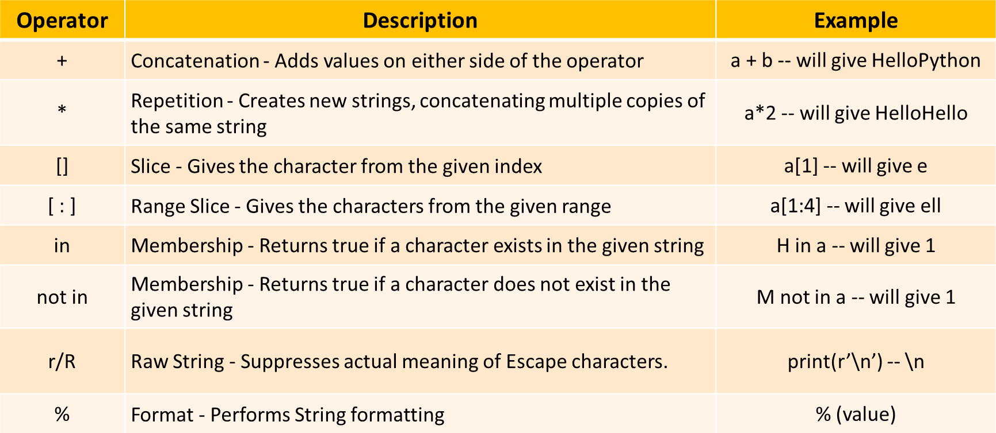

PYTHON TUTORIAL FOR BEGINNERS
Chapter - 13
Strings in Python (Part-2)
- String Indexing
- String Slicing
- String Methods

String Indexing
You can access individual characters in a string using their index. Python uses zero-based
indexing, meaning the first character has an index of 0. Index: Position of the character.

Syntax:
string[Index_Value]

Example:
name = "MADHAV"

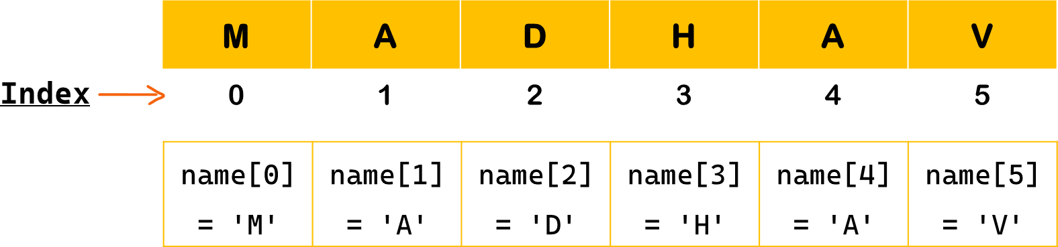

String Indexing – Positive & Negative Index

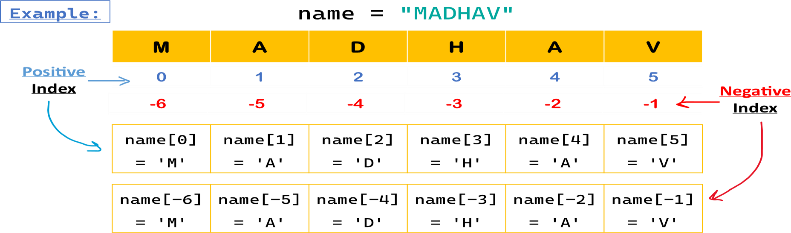

String Slicing
Slicing in Python is a feature that enables accessing parts of the sequence. String slicing allows you to get subset of characters from a string using a specified range of indices.

Syntax:
string[start : end : step]

- start : The index to start slicing (inclusive). Default value is 0.
- end : The index to stop slicing (exclusive). Default value is length of string.
- Step : How much to increment the index after each character. Default value is 1.


Example:

name = "MADHAV" name[0:2] = 'MA'
name[0:5:2] = 'MDA'

String Slicing - Examples

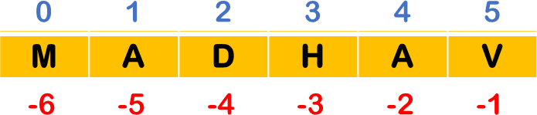
Example:

name = "MADHAV"

name[0:1] | = | name[:1] | = | 'M' | # | first | char
name[0:2] | = | name[:2] | = | 'MA' | # | first | 2 chars
name[2:5] | = | 'DHA' |  |  | # | third | to fifth chars
name[5:] = name[-1:] |  |  | = | 'V' | # | last char
name[4:] = name[-2:] |  |  | = | 'AV' | # | last 2 chars
name[0:5:2] = name[0::2] = 'MDA' # every second chars name[1:-1] = 'ADHA' # exclude first & last chars name[:] = name[::] = 'MADHAV' # all chars
name[::-1] = 'VAHDAM' # reverse the string

String Methods
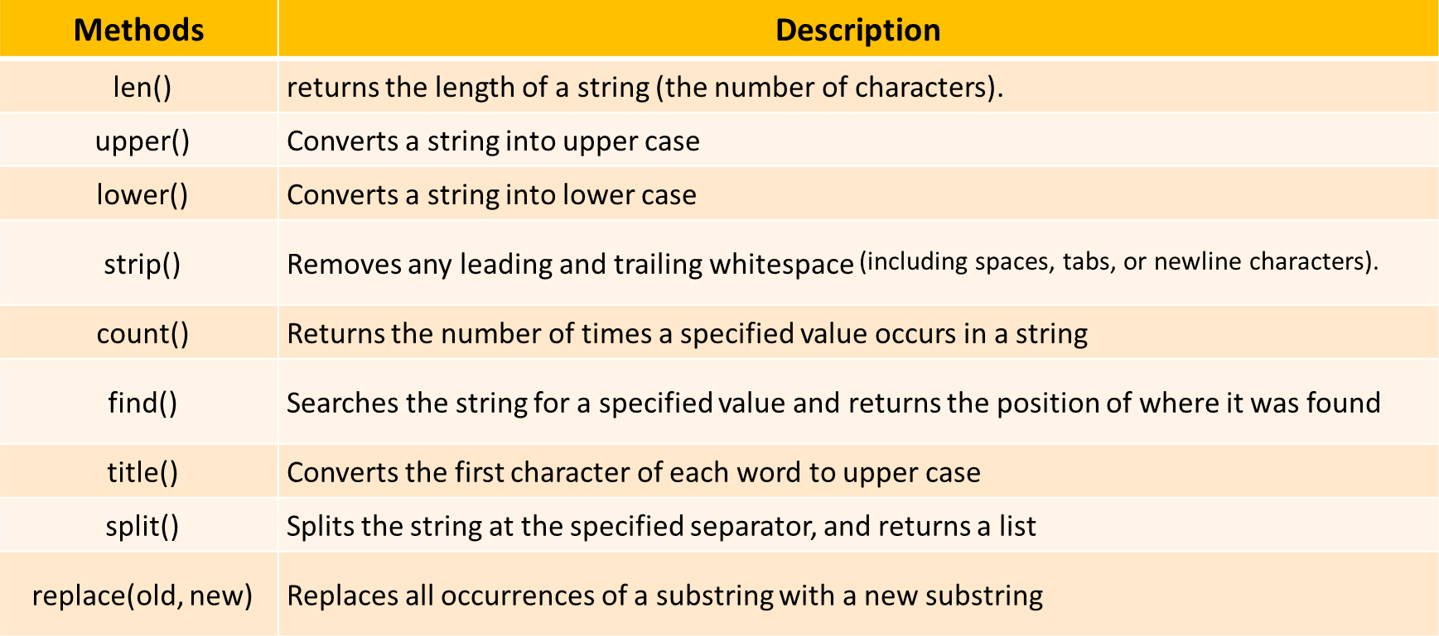

PYTHON TUTORIAL FOR BEGINNERS
Chapter - 14
Loops in Python
- Loops & Types
- While Loop
- For Loop
- Range Function
- Loop Control Statements

Loops in Python
Loops enable you to perform repetitive tasks efficiently without writing redundant code. They
iterate over a sequence (like a list, tuple, string, or range) or execute a block of code as long as a specific condition is met.

Types of Loops in Python
- While loop
- For loop
- Nested loop

While Loop
The while loop repeatedly executes a block of code as long as a given condition remains
True. It checks the condition before each iteration.
Syntax:
while condition:
# Code block to execute
Example: Print numbers from 0 to 3
count = 0
while count < 4: # Condition
print(count) count += 1
# Output: 0 1 2 3

While Loop Example
else Statement: An else clause can be added to loops. It executes after the loop finishes normally (i.e., not terminated by break). Example:
count = 3
while count > 0: # Condition print("Countdown:", count) count -= 1

else:
print("Liftoff!") # Run after while loop ends

For Loop
The for loop in Python is used to iterate over a sequence (such as a list, tuple, dictionary, set, or string) and execute a block of code for each element in that sequence.

Syntax:
for variable in sequence:
# Code block to execute
Example: iterate over each character in language
language = 'Python’
for x in language:
print(x) # Output: P y t h o n

Using range() Function
To repeat a block of code a specified number of times, we use the range() function. The range() function returns a sequence of numbers, starting from 0 by default,
increments by 1 (by default), and stops before a specified number.

Syntax:
range(stop) range(start, stop) range(start, stop, step)

  - start: (optional) The beginning of the sequence. Defaults is 0. (inclusive)
  - stop: The end of the sequence (exclusive).
  - step: (optional) The difference between each number in the sequence. Defaults is 1.

range() Function Example
Example1: Basic usage with One Argument - Stop
for i in range(5): print(i)
# Output: 0 1 2 3 4
Example2: Basic usage with Start, Stop and Step
for i in range(1, 10, 2): print(i)
# Output: 1 3 5 7 9

For Loop Example
else Statement: An else clause can be added to loops. It executes after the loop finishes normally (i.e., not terminated by break).

Example:

for i in range(3): print(i)

else:
print("Loop completed")
# Output: 0 1 2 Loop Completed

while loop VS for loop

while loop
    - A while loop keeps running as long as a condition is true.
    - It is generally used when you don’t know how many iterations will be needed beforehand, and loop continues based on a condition.

for loop
    - A for loop iterates over a sequence (like a strings, list, tuple, or range) and runs the loop for each item in that sequence.
    - It is used when you know in advance how many times you want to repeat a block of code.

Loop Control Statements
Loop control statements allow you to alter the normal flow of a loop. Python supports 3 clauses within loops:

    - pass statement
    - break Statement
    - continue Statement

Loop Control - pass Statement
pass Statement: The pass statement is used as a placeholder (it does nothing) for the future code, and runs entire code without causing any syntax error. (already covered in functions)

Example:

for i in range(5):
# code to be updated

pass

Above example, the loop executes without error using pass statement

Loop Control - break Statement
break Statement: The break statement terminates the loop entirely, exiting from it immediately.

Example:

for i in range(5):
if i == 3:

break
print(i) # Output: 0 1 2

Above example, the loop terminated when condition met true for i == 3

Loop Control - continue Statement
continue Statement: The continue statement skips the current iteration and moves to the next one.

Example:

for i in range(5):
if i == 3:

continue
print(i) # Output: 0 1 2 4

Above example, the loop skips when condition met true for i == 3

break vs continue Statement break Statement example
# pass statement
count = 5
while count > 0: if count == 3:

pass
else:
print(count) count -= 1

# Output: 5 4 2 1

continue Statement example
# continue statement: don't try - infinite loop
count = 5
while count > 0: if count == 3:

# continue
else:
print(count) count -= 1

# Output: 5 4 3 3…….

Validate User Input
# validate user input: controlled infinite while loop using
break statement

while True:
user_input = input("Enter 'exit' to STOP: ")
if user_input == 'exit':
print("congarts! You guessed it right!")

break
print("sorry, you entered: ", user_input)

PYTHON TUTORIAL FOR BEGINNERS
Chapter - 15
Nested Loops in Python
- Nested Loops Definition
- Nested Loops Examples
- Nested Loops Interview Ques

Nested Loops in Python
Loop inside another loop is nested loop. This means that for every single time the outer loop runs, the inner loop runs all of its iterations.

Why Use Nested Loops?
- Handling Multi-Dimensional Data: Such as matrices, grids, or lists of lists.
- Complex Iterations: Operations depend on multiple variables or dimensions.
- Pattern Generation: Creating patterns, such as in graphics or games.

Nested Loop Syntax

Syntax:

Outer_loop:
inner_loop:
# Code block to execute - inner loop # Code block to execute - outer loop

Nested Loop Example
Example: Print numbers from 1 to 3, for 3 times using for-for
nested loop

for i in range(3): # Outer for loop (runs 3 times)
for j in range(1,4): print(j)
print()

Example: Print numbers from 1 to 3, for 3 times using while-for nested loop

i = 1
while i < 4: # Outer while loop (runs 3 times)
for j in range(1, 4): print(j)

print()
i += 1

Nested Loop Interview Question
Example: Print prime numbers from 2 to 10

for num in range(2, 10):
for i in range(2, num): if num % i == 0:
break
else:
print(num)

PYTHON TUTORIAL FOR BEGINNERS
Chapter - 16 List in Python
- What is List
- Create Lists
- Access List: Indexing & Slicing
- Modify List
- List Methods
- Join Lists
- List Comprehensions
- Lists Iteration

List in Python
A list in Python is a collection of items (elements) that are ordered, changeable
(mutable), and allow duplicate elements.
Lists are one of the most versatile data structures in Python and are used to store multiple items in a single variable.
Example:
fruits = ["apple", "orange", "cherry", "apple"] print(fruits)
# Output: ['apple', 'orange', 'cherry', 'apple']

Create List in Python
You can create lists in Python by placing comma-separated values between square brackets []. Lists can contain elements of different data types, including other lists.

Syntax: list_name = [element1, element2, element3, ...]
# List of strings
colors = ["red", "green", "blue"]
# List of integers numbers = [1, 2, 3, 4, 5] # Mixed data types
mixed = [1, "hello", 3.14, True]
# Nested list
nested = [1, [2, 3], [4, 5, 6]]

Accessing List Elements - Indexing
You can access elements in a list by referring to their index. Python uses zero-based
indexing, meaning the first element has an index of 0.

Syntax: | list_name[index]
Example:
fruits = | ["apple", "orange", | "cherry", "apple", "mango"]


# Access first element print(fruits[0]) # Output: apple # Access third element print(fruits[2]) # Output: cherry
# Access last element using negative index
print(fruits[-1]) # Output: mango

List Slicing
Slicing allows you to access a range of elements in a list. You can specify the start and stop indices, and Python returns a new list containing the specified elements.
Syntax: list_name[start:stop:step]

Example: numbers = [10, 20, 30, 40, 50, 60]

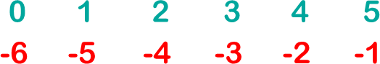

# Slice from index 1 to 3
print(numbers[1:4]) # Output: [20, 30, 40]
# Slice from start to index 2
print(numbers[:3]) # Output: [10, 20, 30]

# Slice all alternate elements
print(numbers[0::2]) # Output: [10, 30, 50]

# Slice with negative indices
print(numbers[-4:-1]) # Output: [30, 40, 50]

# Reverse list
print(numbers[::-1]) # Output: [60,50,40,30,20,10]

Modifying List
Lists are mutable, meaning you can change their content after creation. You can add, remove, or change elements in a list.

# Initial list: fruits = ["apple", "banana", "cherry"]

# Changing an element
fruits[1] = "blueberry"
print(fruits) # Output: ['apple', 'blueberry', 'cherry']

# Adding an element
fruits.append("mango")
print(fruits) # Output: ['apple', 'blueberry', 'cherry’, 'mango']

# Removing an element
fruits.remove("cherry")
print(fruits) # Output: ['apple', 'blueberry', 'mango']

List Methods
Python provides several built-in methods to modify and operate on lists. Eg:

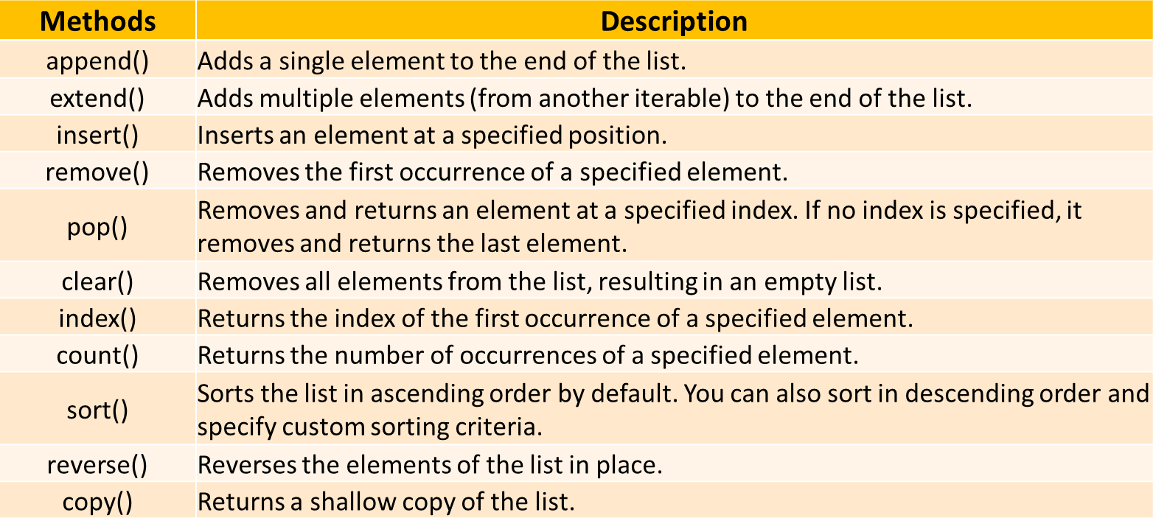

Join Lists
There are several ways to join, or concatenate, two or more lists in Python.
list1 = [1, 2] list2 = ["a", "b"]

# One of the easiest ways are by using the + operator list3 = list1 + list2
print(list3) # Output: [1, 2, 'a', 'b']

# using append method
for x in list2: list1.append(x)
# appending all the items from list2 into list1, one by one
print(list1) # Output: [1, 2, 'a', 'b']

# using extend method
list1.extend(list2) # add elements from one list to another list
print(list1) # Output: [1, 2, 'a', 'b']

List Comprehensions
List comprehensions provide a concise way to create lists. They consist of brackets containing an expression followed by a for clause, and optionally if clauses.

# Syntax:
new_list = [expression for item in iterable if condition]

# Creating a list of squares:
squares = [x**2 for x in range(1, 6)] print(squares) # Output: [1, 4, 9, 16, 25]

# Filtering even numbers:
even_numbers = [x for x in range(1, 11) if x % 2 == 0] print(even_numbers) # Output: [2, 4, 6, 8, 10]

# Applying a function to each element:
fruits = ["apple", "banana", "cherry"] uppercase_fruits = [fruit.upper() for fruit in fruits]
print(uppercase_fruits) # Output: ['APPLE', 'BANANA', 'CHERRY']

List Comprehensions - Flatten a List

Flatten a Nested List - using List Comprehension
def flatten_list(lst):
return [item for sublist in lst for item in sublist]

# Example
nested_list = [[1, 2], [3, 4], [5, 6]] flattened = flatten_list(nested_list) print(flattened)
# Output: [1, 2, 3, 4, 5, 6]

Iterating Over Lists
Iterating allows you to traverse each element in a list, typically using loops.
#Example: fruits = ["apple", "banana", "cherry"]

# Using for loop for fruit in fruits:
print(fruit)

# Using while loop
index = 0
while index < len(fruits): print(fruits[index]) index += 1

PYTHON TUTORIAL FOR BEGINNERS
Chapter - 17
Tuple in Python
- What is Tuple
- Create Tuples
- Access Tuples: Indexing & Slicing
- Tuple Operations
- Tuple Iteration
- Tuple Methods
- Tuple Functions
- Unpack Tuples
- Modify Tuple

Tuple in Python
A tuple is a collection of items in Python that is ordered, unchangeable (immutable) and allow duplicate values.
Tuples are used to store multiple items in a single variable.
Note: Ordered – Tuple items have a defined order, but that order will not change.
Example:
fruits = ("apple", "orange", "cherry", "apple") print(fruits)
# Output: ('apple', 'orange', 'cherry', 'apple')

Create Tuple in Python
There are several ways to create a tuple in Python:

Using Parentheses ()
colors = ("red", "green", "blue") numbers = (1, 2, 3, 4, 5)
mixed = (1, "hello", 3.14, True)
nested = (1, [2, 3], (4, 5, 6))

Without Parentheses (Comma-Separated)
also_numbers = 1, 2, 3, 4, 5

Using the tuple() Constructor
new_tuple = tuple(("apple", "banana", "cherry")) # use doble brackets
list_items = ["x", "y", "z"] # Creating a tuple from a list
tuple_items = tuple(list_items) # ('x', 'y', 'z’)

Single-Item Tuple
tuplesingle = ("only",)

Accessing Tuple Elements - Indexing
You can access elements in a tuple by referring to their index. Python uses zero-based
indexing, meaning the first element has an index of 0.
Syntax: tuple_name[index]

Example:
fruits = ("apple", "orange", "cherry", "apple", "mango")

# Access first element
print(fruits[0]) # Output: apple
# Access third element
print(fruits[2]) # Output: cherry
# Access last element using negative index
print(fruits[-1]) # Output: mango

Tuple Slicing
Slicing allows you to access a range of elements in a tuple. You can specify the start and stop indices, and Python returns a new tuple containing the specified elements.
Syntax: tuple_name[start:stop:step]

Example:
numbers = (10, 20, 30, 40, 50, 60)

# Slice from index 1 to 3
print(numbers[1:4]) # Output: (20, 30, 40)
# Slice from start to index 2
print(numbers[:3]) # Output: (10, 20, 30)
# Slice all alternate elements
print(numbers[0::2]) # Output: (10, 30, 50)
# Slice with negative indices
print(numbers[-4:-1]) # Output: (30, 40, 50)
# Reverse list
print(numbers[::-1]) # Output: (60,50,40,30,20,10)

Tuple Operations
- Concatenation
# You can join two or more tuples using the + operator.
tuple1 = (1, 2, 3)
tuple2 = (4, 5)
combined = tuple1 + tuple2
print(combined) # Output: (1, 2, 3, 4, 5)

Repetition
# You can repeat a tuple multiple times using the * operator.
tuple3 = ("hello",) * 3
print(tuple3) # Output: ('hello', 'hello', 'hello’)

Checking for an Item
# Use the in keyword to check if an item exists in a tuple.
numbers = (10, 20, 30, 40)
print(20 in numbers) # Output: True

Iterating Over Tuple
Iterating allows you to traverse each element in a tuple, using loops.
#Example: fruits = ("apple", "mango", "cherry")
# Using for loop for fruit in fruits:
print(fruit)

# Using while loop

i = 0
while i < len(fruits): print(fruits[i]) index += 1

Tuple Methods
Python provides two built-in methods to use on tuples.
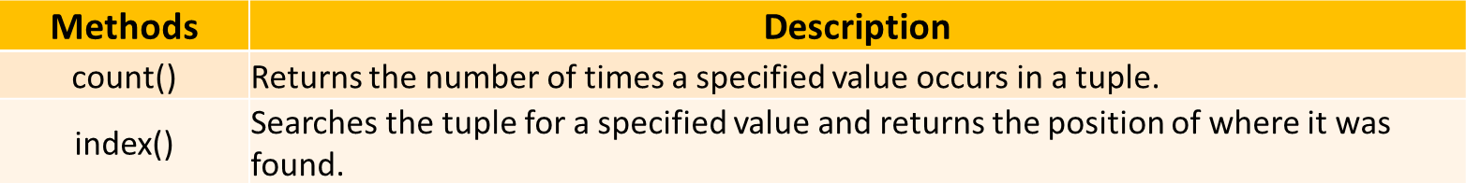

# count
colors = ("red", "green", "blue", "green") print(colors.count("green")) # Output: 2

# index
colors = ("red", "green", "blue", "green") print(colors.index("blue")) # Output: 2

Tuple Functions
Python provides several built-in functions to use on tuples.
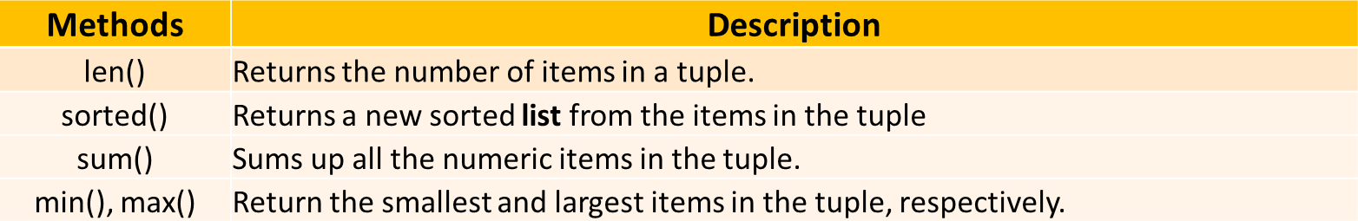

numbers = (2, 3, 1, 4) print(len(numbers)) # Output: 4
sorted_num = sorted(numbers) print(sorted_num) # Output: [1,2,3,4]

print(sum(numbers)) | # | Output: | 10
print(min(numbers)) | # | Output: | 1
print(max(numbers)) | # | Output: | 4

Packing and Unpacking Tuples
  - Packing is the process of putting multiple values into a single tuple.
a = "Madhav"
b = 21
c = "Engineer"
pack_tuple = a,b,c # Packing values into a tuple
print(pack_tuple)
  - Unpacking is extracting the values from a tuple into separate variables.
name, age, profession = person # Unpacking a tuple
print(name) | # | Output: | Madhav
print(age) | # | Output: | 21
print(profession) | # | Output: | Engineer

Modifying Tuple - Immutable

Once a tuple is created, you cannot modify its elements. This means you cannot add, remove, or change items.
# Creating a tuple
numbers = (1, 2, 3)

# Attempting to change an item
numbers[0] = 10
# This will raise an error


Modifying Tuple
But there is a trick. You can convert the tuple into a list, change the list, and convert the list back into a tuple.
my_tuple = ("apple", "mango", "cherry")

# type cast tuple to list y = list(my_tuple) y.append("orange")

# type cast back list to tuple my_tuple = tuple(y) print(my_tuple)

Tuple Use Case - Examples
Storing Fixed Data (Immutable Data)
Example: Storing geographic coordinates (latitude, longitude) or RGB color values, where the values shouldn’t be changed after assignment.
coordinates = (40.7128, -74.0060) # Latitude and longitude for NYC
rgb_color = (255, 0, 0) # RGB value for red

Using Tuples as Keys in Dictionaries
Since tuples are immutable and hashable, they can be used as keys in dictionaries, unlike lists.
location_data = {
(40.7128, -74.0060): "New York City",
(34.0522, -118.2437): "Los Angeles"
}
print(location_data[(40.7128, -74.0060)]) # Output: New York City

PYTHON TUTORIAL FOR BEGINNERS
Chapter - 18
Set in Python
- What is a Set
- Create Sets
- Set Operations
- Set Methods
- Set Iteration
- Set Comprehensions

Set in Python
A set is a collection of unique items in Python. Sets do not allow duplicate items and do not maintain any particular order so it can’t be indexed.

Characteristics of Sets:
- Unordered: Elements have no defined order. You cannot access elements by index.
- Unique Elements: No duplicates allowed. Each element must be distinct.
- Mutable: You can add or remove elements after creation.
- Immutable Elements: individual elements inside a set cannot be modified/replaced

Example:
vowels = {'a', 'e', 'i', 'o', 'u'}

Create Set in Python
There are two primary ways to create a set in Python:

Using Curly Braces {}
my_set = {1, 2, 3, 4, 5}
print(my_set) # Output: {1, 2, 3, 4, 5}

Using the set() Constructor
my_set = set([1, 2, 3, 4, 5])
print(my_set) # Output: {1, 2, 3, 4, 5}

Note: An empty set cannot be created using {} as it creates an empty dictionary. Use set() instead.
empty_set = set() print(empty_set) # Output: set()

Set Operations
- Adding Elements : Use the add() method to add a single element to a set.
fruits = {'apple', 'banana'} fruits.add('cherry')
print(fruits) # Output: {'apple', 'banana', 'cherry’}

- Removing Elements: Use the remove() or discard() methods to remove elements.
  - remove() raises an error if the element is not found.
  - discard() does not raise an error if the element is missing.
fruits = {'apple', 'banana', 'cherry'}

# Using remove()
fruits.remove('banana')
print(fruits) # Output: {'apple', 'cherry'}

# Using discard()
fruits.discard('orange') # No error even if 'orange' is not in the set
print(fruits) # Output: {'apple', 'cherry’}

Set Methods
- Union: Combines elements from two sets, removing duplicates.
set_a = {1, 2, 3}
set_b = {3, 4, 5}
union_set = set_a.union(set_b) print(union_set) # Output: {1, 2, 3, 4, 5}

Alternative Syntax: union_set = set_a | set_b

- Intersection: Includes only elements present in both sets.
set_a = {1, 2, 3}
set_b = {2, 3, 4}
intersection_set = set_a.intersection(set_b) print(intersection_set) # Output: {2, 3}

Alternative Syntax: intersection_set = set_a & set_b

- Difference: Elements present in the first set but not in the second.
set_a = {1, 2, 3, 4}
set_b = {3, 4, 5}
difference_set = set_a.difference(set_b) print(difference_set) # Output: {1, 2}

Alternative Syntax: difference_set = set_a - set_b

- Symmetric Difference: Elements in either set, but not in both.

set_a = {1, 2, 3}
set_b = {3, 4, 5}
sym_diff_set = set_a.symmetric_difference(set_b) print(sym_diff_set) # Output: {1, 2, 4, 5}

Alternative Syntax: sym_diff_set = set_a ^ set_b

Set Iterations – Loop
You can use a for loop to go through each element in a set.

# Using for loop - Printing each number from a set
numbers = {1, 2, 3, 4, 5}
for number in numbers: print(number)

# Using while loop - first convert set to a list then use while loop because sets do not support indexing.

Set Comprehension
Set comprehensions allow concise and readable creation of sets. Similar to list comprehensions but for sets.

# Syntax:
new_set = {expression for item in iterable if condition}

# Example:
squares = {x**2 for x in range(1, 6)} print(squares) # Output: {1, 4, 9, 16, 25}

Set Common Use Cases
- Removing Duplicates: Easily eliminate duplicate entries from data.
- Membership Testing: Quickly check if an item exists in a collection.
- Set Operations: Perform mathematical operations like union, intersection, and difference.
- Data Analysis: Useful in scenarios requiring unique items, such as tags, categories, or unique identifiers.

# Example: Removing Duplicates from a List numbers = [1, 2, 2, 3, 4, 4, 5] unique_numbers = set(numbers)
print(unique_numbers) # Output: {1, 2, 3, 4, 5}

PYTHON TUTORIAL FOR BEGINNERS
Chapter - 19
Dictionary in Python
- What is a Dictionary
- Create Dictionary
- Access Dictionary Values
- Dictionary Methods
- Dictionary – Add, Modify & Remove Items
- Dictionary Iteration
- Nested Dictionary
- Dictionary Comprehensions

Dictionary in Python
A dictionary is a data structure in Python that stores data in key-value pairs. Dictionary items (key – value pair) are ordered, changeable, and do not allow duplicates.
- Key: Must be unique and immutable (strings, numbers, or tuples).
- Value: Can be any data type and does not need to be unique.

Example: Simple dictionary with three key-value pairs
student = {
1: "Class-X",
"name": "Madhav", "age": 20
}

Create Dictionary in Python
Method-1: We create a dictionary using curly braces {} and separating keys and values with a colon.

# Syntax
my_dict =
{"key1": "value1", "key2": "value2", "key3": "value3", …}

# Empty dictionary
empty_dict = {}

# Dictionary with data
cohort = {
"course": "Python", "instructor": "Rishabh Mishra", "level": "Beginner"
}

Method-2: Using dict() constructor
Pass key-value pairs as keyword arguments to dict()

person = dict(name="Madhav", age=20, city="Mathura") print(person)

# Output: {'name': 'Madhav', 'age’: 20, 'city':
'Mathura'}

Method-3: Using a List of Tuples
Pass a list of tuples, where each tuple contains a key-value pair.

student = dict([("name", "Madhav"), ("age", 20), ("grade", "A")])
print(student)

# Output: {'name': 'Madhav', 'age’: 20, 'grade': 'A'}

Access Dictionary Values
Access dictionary values by using the key name inside square brackets.

Example:

student = {
1: "Class-X",
"name": "Madhav", "age": 20

}

# print value based on respective key-names print(student["name"]) # Output: Madhav print(student["age"]) # Output: 20

Dictionary Methods
Python provides several built-in methods to use on dictionary.
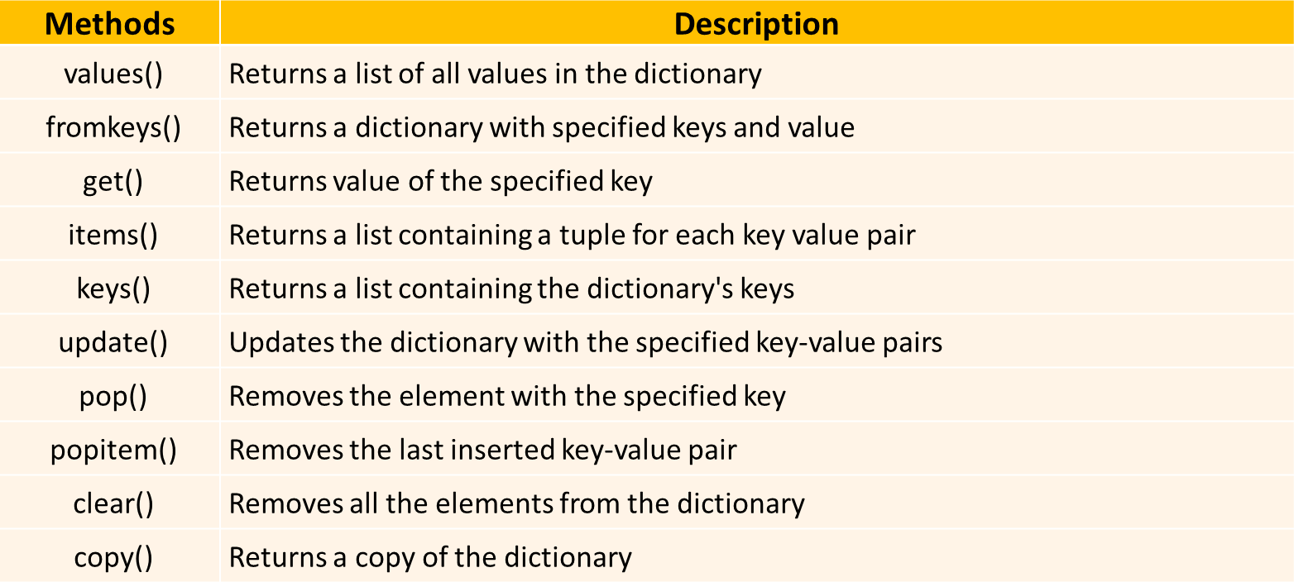

Here are a few useful methods:
  - .keys(): Returns all keys in the dictionary.
  - .values(): Returns all values in the dictionary.
  - .items(): Returns all key-value pairs.
  - .get(): Returns value for a key (with an optional default if key is missing).

Examples  print(student.keys()) | # | All | keys
print(student.values()) | # | All | values
print(student.items()) | # | All | key-value pairs
print(student.get("name")) # Safe way to access a value

Dictionary – Add, Modify & Remove Items
- Add or Modify Item: Use assign-operator '=' to add/modify items in a dictionary.

# Adding a new key-value pair
student["email"] = "madhav@example.com"

# Modifying an existing value
student["age"] = 25

- Remove Item: Use del or .pop() to remove items from a dictionary.

# Remove with del
del student["age"]

# Remove with pop() and store the removed value
email = student.pop("email")
print(email) # Output: madhav@example.com

Dictionary Iterations
A dictionary can be iterated using for loop. We can loop through dictionaries by keys, values, or both.

# Loop through keys
for key in student: print(key)
# Loop through values
for value in student: print(student[value])
# Loop through values: using values() method
for value in student.values(): print(value)
# Loop through both keys and values
for key, value in student.items(): print(key, value)

Nested Dictionary
Dictionaries can contain other dictionaries, which is useful for storing more complex data.
# nested dictionaries
students = {
"student1": {
"name": "Madhav", "age": 20,
"grade": "A"
},
"student2": {
"name": "Keshav", "age": 21,
"grade": "B"
}
}
print(students["student1"]["name"]) # Output: Madhav

Dictionary Comprehension
A dictionary comprehension allows you to create dictionaries in a concise way.

# Syntax:
new_dict =
{key_expression: value_expression for item in iterable if
condition}

# Example: Creating | a dictionary with | square numbers
squares = {x: x * x | for x in range(1, | 6)}
print(squares)
# Output: {1: 1, 2: | 4, 3: 9, 4: 16, 5: 25}

Dictionary Common Use Cases
  - User Profiles in Web Applications: Store user details like name, email, etc.
  - Product Inventory Management: Keep track of stock levels for products in an e-commerce system.
  - API Responses: Parse JSON data returned from APIs (e.g., weather data).
  - Grouping Data: Organize data into categories. Example: grouped = {"fruits": ["apple", "banana"], "veggies": ["carrot"]}
  - Caching: Store computed results to reuse and improve performance. Example: cache = {"factorial_5": 120}
  - Switch/Lookup Tables: Simulate switch-case for decision-making.

# Example:
actions = {"start": start_fn, "stop": stop_fn} actions["start"]()

PYTHON TUTORIAL FOR BEGINNERS

Chapter - 20
OOPs in Python
- What is OOPs
- Why OOP is required
- Class and Object
- Attributes and Methods
- init Method (Constructor)
- Abstraction
- Encapsulation
- Inheritance
- Polymorphism

OOPs in Python

Two ways of programming in Python:
- Procedural Programming,

OOPs

OOPs: Object Oriented Programming
A way of organizing code by creating "blueprints" (called classes) to represent real-world things like a student, car, or house. These blueprints help you create objects (individual examples of those things) and define their behavior.

Class: A class is a blueprint or template for creating objects.
It defines the properties (attributes) & actions/behaviors (methods) that objects of this type will have.

Object: An object is a specific instance of a class.
It has actual data based on the blueprint defined by the class.

OOPs Example in Python Example: Constructing a building Class: Blueprint for a floor.
Object: Actual house built from the blueprint. Each house (object) can have different features, like paint color or size, but follows the same blueprint.



Why OOPs?
- Models Real-World Problems:
Mimics real-world entities for easier understanding.

Code Reusability:
Encourages reusable, modular, and organized code.

Easier Maintenance:
OOP organizes code into small, manageable parts (classes and objects). Changes in one part don’t impact others, making it easier to maintain.

Encapsulation:
Encapsulation protects data integrity and privacy by bundling data and methods within objects.

Flexibility & Scalability:
OOP makes it easier to add new features without affecting existing code.

OOPs – Question
Write a Python program to:
- Define a Student class with attributes name, grade, percentage, and team.
  - Include an init method to initialize these attributes.
  - Add a method student_details that prints the student’s details in the format: "<name> is in <grade> grade with <percentage>%, from team <team>".
- Create two teams (team1 and team2) as string variables.
- Create at least two student objects, each belonging to one of the teams.
- Call the student_details method for each student to display their details.

Class and Object Example
Class: A class is a blueprint or template for creating objects.
Object: An object is a specific instance of a class.
Example
class Student: pass
# Create an object student1 = Student() print(type(student1))
# Output: <class ' main .Student'>

Attributes and Methods
Attributes: Variables that hold data about the object.
Methods: Functions defined inside a class that describe its behavior.
Example
class Student:
def init (self, name, grade): self.name = name # Attribute self.grade = grade # Attribute
def get_grade(self): # Method
return f"{self.name} is in grade {self.grade}."

# Object creation
student1 = Student("Madhav", 10)
print(student1.get_grade()) # Output: Madhav is in grade 10.

The __init__ Method (Constructor)
Whenever we create/construct an object of a class, there is an inbuilt method init
which is automatically called to initialize attributes.
The self parameter is a reference to the current instance of the class, and is used to access variables that belong to the class.
Example
class Student:
def init (self, name, grade): self.name = name
self.grade = grade
# Initialize object with attributes student1 = Student("Madhav", 10) print(student1.name) # Output: Madhav

Abstraction in Python: Hiding unnecessary details
Abstraction hides implementation details and shows only the relevant functionality to the user.
Example
class Student:
def init (self, name, grade, percentage): self.name = name
self.grade = grade self.percentage = percentage

def is_honors(self): # Abstracting the logic
return self.percentage > 90 # Logic hidden # Abstract method in use
student1 = Student("Madhav", 10, 98) print(student1.is_honors()) # Output: True

Encapsulation in Python: Restricting direct access to attributes & methods
Encapsulation restricts access to certain attributes or methods to protect the data and enforce controlled access.
Example
class Student:
def init (self, name, grade, percentage): self.name = name
self.grade = grade
self. percentage = percentage # Private attribute (hidden)
def get_percentage(self): # Public method to access the private attribute
return self. percentage

# Creating a student object
student1 = Student("Madhav", 10, 98)

# Accessing the private attribute using the public method
print(f"{student1.name}'s percentage is
{student1.get_percentage()}%.") print(student1. percentage) # error

Inheritance in Python: Reusing Parent’s prop & methods
Inheritance (parent-child), allows one class (child) to reuse the properties and methods of another class (parent). This avoids duplication and helps in code reuse.
Example
class Student:
def init (self, name, grade, percentage): self.name = name
self.grade = grade self.percentage = percentage
def student_details(self): # method
print(f'{self.name} is in {self.grade} grade with
{self.percentage}%')

class GraduateStudent(Student): # GraduateStudent inherits from Student

def init (self, name, grade, percentage, stream):
super(). init (name, grade, percentage) # Call parent class initializer
self.stream = stream # New attribute specific to GraduateStudent

def student_details(self): super().student_details() print(f"Stream: {self.stream}")

# Create a graduate student
grad_student = GraduateStudent("Vishakha", 12, 94, "PCM")
# Vishakha is in 12 grade with 94%
grad_student.student_details() # Stream: PCM

Polymorphism in Python: Same method but different output
Polymorphism allows methods in different classes to have the same name but behave differently depending on the object.

Example
class GraduateStudent(Student):
def student_details(self): # Same method as in parent class
print(f"{self.name} is a graduate student from final
year.")

# Polymorphism in action
student1 = Student("Madhav", 10, 98)
grad_student = GraduateStudent("Sudevi", 12, 99, "PCM") student1.student_details()
# Output: Madhav is in 10 grade with 98%

grad_student.student_details()
# Output: Sudevi is a graduate student from final year.

PYTHON TUTORIAL FOR BEGINNERS
Chapter - 21
Modules, Packages & Libraries in Python
- What is Module
- Create & Use a Module
- What is Package
- What is Library
- Python pip
- Most used Libraries

Modules in Python
A module is a single Python file (.py) containing Python code. It can include functions, classes, and variables that you can reuse in other programs.

Why use modules?
- To organize code into smaller, manageable chunks.
- To reuse code across multiple programs.

# Create a module:
- Save the following as mymodule.py

def say_hello(name):
return print(f"Hello, {name}!")

# Use the module:
import mymodule greetings.say_hello("Madhav") # Output: Hello, Madhav!

Packages in Python
A package is a collection of modules organized in directories (folders) with an init .py file. It allows you to structure your Python projects logically.

Why use packages?
- To group related modules together.
- To create larger applications or libraries.

# Structure Example:
my_package/
init .py math_utils.py string_utils.py

# Use the package:
Syntax: from my_package import <package_name>
Example: from my_package import math_utils, string_utils

Libraries in Python
A library is a collection of modules and packages that provide pre-written functionality for your program. Libraries are typically larger and more feature-rich than packages or modules.

Why use libraries?
To avoid writing common functionality from scratch.
To leverage powerful tools developed by the community.

Example: Python has many popular libraries, such as:
- Pandas: For data manipulation.
- Matplotlib: For plotting and visualization.

# Using a library (Pandas):
import pandas as pd

Python PIP
pip stands for "Pip Installs Packages". It is the package manager for Python that allows you to install, update, and manage Python libraries (packages) from the Python Package Index (PyPI).

Think of pip as an app store for Python libraries. You use it to search, install, and manage Python tools, just like downloading apps on your phone.

When you use pip install <package_name>, it:
- Connects to PyPI (Python Package Index) online.
- Downloads the specified library or package.
- Installs it into your Python environment.

To install packages, we use: pip install <library_name>

Example: installing pandas to work on dataframe:
pip install pandas

Summary: Module, Package and Library

- Module: A single page.
- Package: A book containing multiple pages.
- Library: A book store with many books.

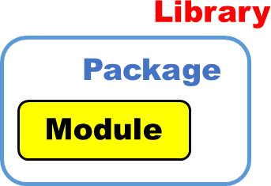

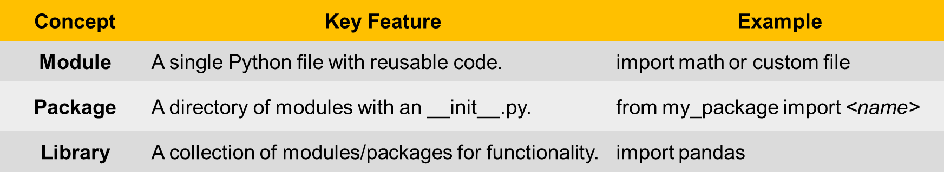

Most Used Python Libraries

Data Analytics, data visualization and ML

Application Library Description Install Command

Data Analytics
Pandas Data manipulation and analysis.
NumPy Numerical computing with array support.
SciPy Scientific computing and technical computing.
Statsmodels Statistical modeling and
testing.
Dask Parallel computing for large datasets.
pip install pandas pip install numpy pip install scipy
pip install statsmodels pip install dask

Data Visualization
Matplotlib Basic plotting and visualization. pip install matplotlib

Seaborn Statistical data visualization. pip install seaborn

Plotly Interactive graphs and dashboards.
Scikit-learn Classic machine learning
algorithms.
pip install plotly

pip install scikit-learn

Machine Learning
TensorFlow Deep learning and ML models. pip install tensorflow
Deep learning with dynamic

& Deep Learning
PyTorch
pip install torch torchvision
computation.

Keras High-level deep learning API. pip install keras

XGBoost Gradient boosting for structured data.
pip install xgboost

Web Scraping, web development and game development

Application | Library | Description Install Command
 | BeautifulSoup | Parsing HTML and XML for data pip install beautifulsoup4  extraction.
 | Scrapy | Advanced web scraping pip install scrapy  framework.
Web Scraping | Selenium | Browser automation for pip install selenium  scraping dynamic sites.
 | Requests | HTTP library for fetching web pip install requests  pages.
 | Lxml | Fast XML and HTML parsing. pip install lxml
 | Django | Full-stack web framework. pip install django
Web Development | Flask | Lightweight web framework. pip install flask
 | FastAPI  Pygame | High-performance API pip install fastapi  framework.  Game development library. pip install pygame
Game Development | Arcade | Advanced 2D game pip install arcade  development library.
 | Panda3D | Real-time 3D rendering and pip install panda3d  game creation.

PYTHON TUTORIAL FOR BEGINNERS
Chapter - 22
File Handling in Python
- What is File Handling
- Open & Read a File
- Write & Append to a File
- Create a File
- Close a file
- Work on txt, csv, excel, pdf files

File handling in Python
File handling in Python allows you to read from and write to files. This is important when you want to store data permanently or work with large datasets.
Python provides built-in functions and methods to interact with files.

Steps for File Handling in Python:
- Opening a file
- Reading from a file
- Writing to a file
- Closing the file

Open a File
To perform any operation (read/write) on a file, you first need to open the file using Python’s open() function.
Syntax: file_object = open('filename', 'mode’)
- 'filename': Name of the file (can be relative or absolute path).
- 'mode': Mode in which the file is opened (read, write, append, etc.).

File Modes:
  - 'r': Read (default mode). Opens the file for reading.
  - 'w': Write. Opens the file for writing (if file doesn’t exist, it creates one).
  - 'a': Append. Opens the file for appending (if file doesn’t exist, it creates one).
  - 'rb'/'wb': Read/Write in binary mode.

Example: Opening a file for reading
file = open('example.txt', 'r')

Read from a File
Once a file is open, you can read from it using the following methods:
  - read(): Reads the entire content of the file.
  - readline(): Reads one line from the file at a time.
  - readlines(): Reads all lines into a list.

# Example: Reading the entire file
file = open('example.txt', 'r') content = file.read() print(content)
file.close()

# Example: Reading one line at a time
file = open('example.txt', 'r') line = file.readline() print(line)
file.close()

Write to a File
To write to a file, you can use the write() or writelines() method:
  - write(): Writes a string to the file.
  - writelines(): Writes a list of strings.

# Example: Writing to a file (overwrites existing content) file = open('example.txt', 'w') file.write("Hello, world!") file.close()

# Example: Appending to a file (add line to the end)
file = open('example.txt', 'a') file.write("\nThis is an appended line.") file.close()

# Close a file:
file.close()

Close a File
Instead of manually opening and closing a file, you can use the with statement, which automatically handles closing the file when the block of code is done.

# Example: Reading with with statement
with open('example.txt', 'r') as file: content = file.read() print(content)
In this case, you don’t need to call file.close(), because Python automatically closes the file when the block is finished.

# Example: Using exception handling to close a file

try:
open('example.txt', 'r') as file: content = file.read() print(content)

finally:
file.close()

Working with Difft Format Files
# csv - Using csv module
import csv
file = open('file.csv', mode='r') reader = csv.reader(file)

# csv - Using pandas library
import pandas as pd
df = pd.read_csv('file.csv')

# excel - Using pandas library
import pandas as pd
df = pd.read_excel('file.xlsx')

# PDF Using PyPDF2 library:
import PyPDF2
file = open('file.pdf', 'b') pdf_reader = PyPDF2.PdfReader(file)

